Some Videos for related topics:

http://www.youtube.com/watch?v=rZ8tVgFyY84

http://www.youtube.com/watch?v=d6veImR2RKQ |  |  |  | - Respiratory Etiquette Video
http://www.youtube.com/watch?v=sbZnn0dZI3s |  |  |  | - Diarrhoea (prevention/hygine practices) Video
http://www.youtube.com/watch?v=lyt6A5TNrds |  |  |  | - How to Alleviate Food Poisoning Video
http://www.youtube.com/watch?v=FQXwMlW1-Q0 |  |  |  | - Personal Protective Measures for Malaria
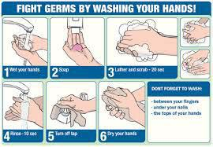

- Proper Hand Washing Technique Video

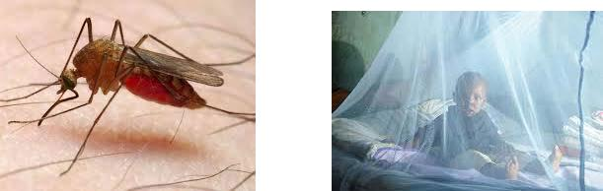

H1N1 MONITORING
Control of Swine Flu:

Under this scheme measures are taken for the control of Swine Flu (H1N1) in the state. Public are made aware about the detection of swine flu cases in the various parts of country as well as world. Advertisements are published in the local newspapers, with a request as, not to panic and to take certain precautions to prevent the disease. Samples i.e. (throat swabs) of suspected patients are sent to NCDC Delhi from Epidemiological cell for investigation on regular basis. Also necessary steps are taken for ensuring surveillance and bio-security in order to prevent spread of disease.

 | April  To  Dec  2009 | Jan  To  Dec  2010 | Jan  To  Dec  2011 | Jan  To  Dec  2012 | Jan  To  Dec  2013 | Jan  To  Dec  2014 | Jan  To  Dec  2015 | Jan  To  Dec  2016 | Jan  To  Dec  2017 | 2018  (till 02/07/18)
Suspected Cases | 306 | 340 | 70 | 79 | 33 | 29 | 898 | 390 | 1106 | 208
Throat Swab Collected | 215 | 320 | 70 | 79 | 33 | 29 | 898 | 390 | 1106 | 208
Reports Recieved | 215 | 320 | 70 | 79 | 33 | 29 | 898 | 390 | 1106 | 208
Positive for Swine Flu | 52 | 62 | 7 | 9 | NIL | 1 | 193 | 6 | 262 | 1
Death Cases | 5 | 1 | NIL | NIL | NIL | 1 | 19 | 0 | 12 | NIL

